ATLANTIC FOREST
ITATIAIA NATIONAL PARK AND UBATUBA RESERVE
(Birdwatching)
1st. Day: Meeting at the airport in São Paulo. Transfer to the Itatiaia National Park. Check in and have lunch. PM: Dedicated to watch fantastic birds at the gardens and bird feeders of our hotel. Possible Birds: Brazilian Ruby, White-throated Hummingbird, Frilled Coquette, Violet-capped Woodnymph, Versicolored Emerald, Dusky-throated & Scaled-throated Hermit, Black Jacobin, Swallow-tailed Hummingbird, Black-eared Fairy ( You might have an Hummingbird Extravaganza, as well, since we might see over 10 (ten) species of hummers!!!). Well, the show has to go on: Dusky-legged Guan, Saffron Toucanet, Green-headed Tanager, White-eyed Foliage-gleaner, White-bibbed Antbird, Star-throated Antwren. Since, we shall stay long enough to watch the Sunset; we also will be looking for Short-tailed Nighthawk and, right after, the Tawny-browed Owl (which has a very weird call), Ferruginous & Least Pygmy-Owl and Variable Screech-owl Return to our hotel.Field Checklist Track (FCT).Dinner. Overnight in Itatiaia.
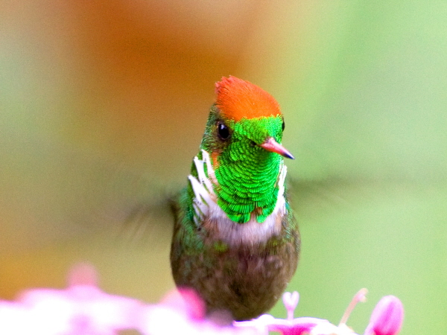
"Frilled Coquette © Lou Hegedous"

2nd. Day: Early breakfast. On this day, we will be birding on the upper part of the National Park, where we shall spend the entire day, having a Box Lunch. "No pain...No gain...": But, our gain shall be excellent: The very rare & endemic Golden-winged Cotinga and Itatiaia Spinetail shall be a good prize for our efforts. There we shall have also the Blue Manakin, White-browed Warbler , Black Hawk-Eagle, Black-breasted Plover-Crest, Great Pampa-Finch, Thick-billed Saltator, Golden-winged Cacique, White-crested Tyrannulet, Blue-billed & Velvety Black-Tyrant, Rufous-tailed Antbird, Streamer-tailed Tyrant and White-bellied Seedeater. Eventually, we will stay long enough to search for Rusty-barred Owl. Return to our Hotel. FCT. And have dinner. Overnight in Itatiaia.
3rd. Day: During this day - morning and afternoon - we will be exploring trails. Returning to the lodge for a nice meal and some rest at noon. We will search carefully for the Endemic Antwrens, such the Star-throated and Ferruginous Antwren. Plus: White-bibbed Antbird, Brown Tanager, Blue-naped Clorophonia, Black-billed Scythbill, Rufous Motmot, Brown Tinamou, Picazuro Pigeon, Maroon-bellied Parakeet, Blue-winged Parrotlet, White-collared Swift, Sick’s Swift, Surucua Trogon,Barred Forest-Falcon, Spot-winged Wood-Quail, Slaty-breasted Wood-Rail, Plumbeous Pigeon, Black-throated Trogon, Yellow-browed Woodpecker, Brazilian & Such's Antthrush, Speckle-breasted Antpitta, Rufous Gnateater, Red-ruffed Fruitcrow, Rough-legged Tyrannulet, Large-headed Flatbill, Brassy-breasted & Gilt-edged Tanager and Blackish-blue Seedeater. We shall stay long enough, again, for some Owling. Return to our hotel. FCT and have dinner; overnight in Itatiaia.

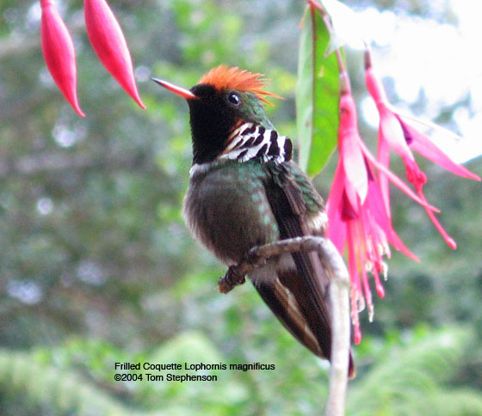
Frilled Coquette

4th. Day: Breakfast and check out, with birding and lunch in route: Rufous-sided Crake, South American Snipe and Firewood Gatherer, will be birds worthy to “break for”. Once we arrive in Ubatuba, we shall make a stop on a wonderful property where we may see the Red-necked Tanager. This place also has a very nice feeder: Saw-billed Hermit, Somber Hummingbird and Festive Coquette! Arrival at the lodge and check in. Eventually, we may have some time for a walk and birding on the beach looking for Kelp Gull & Brown Bobby . Dinner and FCT. Overnight in Ubatuba.
5th. and 6th Day : Two wonderful days when we will l be exploring this marvelous area, in both mornings & afternoons, with a nice break for lunch in both days. In Ubatuba, we will have chances for fantastic birds, such: Bare-throated Bellbird, White-shouldered Fire-eye, Streak-capped Antwren, Slaty Bristelfront, Buff-throated Purpletuft, White-bearded Manakin, Sharpbill, Mantle Hawk, Gray-hooded Flycatcher, Long-billed Wren, Black-cheeked Gnateater, Rufous-winged Antwren, Scaled Antbird, Rufous-capped Antthrush, Lesser Woodcreeper, Channel-billed Toucan, Fork-tailed Tody-flycatcher, Long-billed Gnatwren, Spotted Bamboowren, Uniform Crake, Ruddy Quail-Dove, Spot-backed Antshrike, Eye-ringed Tody-flycatcher, Long-billed Wren, White-tailed Trogon, Slaty Bristlefront and Rufous-capped Antthrush., Spot-breasted Antvireo, Blond-crested & Yellow-throated Woodpecker. Owling can be very productive here: Mottled Owl, Long-tufted Screech-owl, Least Pygmy-Owl and Pauraque. Return to our hotel. FCT and have dinner. Overnight in Ubatuba.

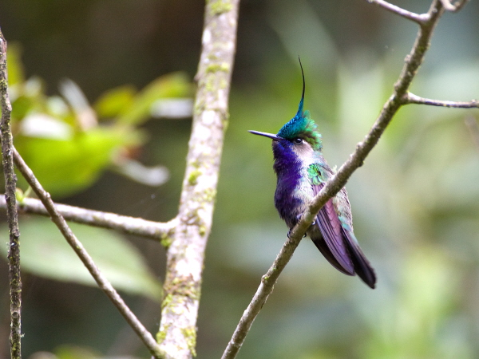
"Plovercrest © Lou Hegedous"

7th. Day: Breakfast. AM: This morning we will be birding for possible missing species. Lunch and return to the lodge for checking out. Transfer to the airport in São Paulo.

Price 2012: Atlantic Forest - Itatiaia National Park and Ubatuba Reserve
Group of 02 and 03 people: US$2,792.00 per person in double room
Group of 04 and 05 people: US$2,375.00 per person in double room
Group of 06 and 07 people: US$1,964.00 per person in double room
Group of 08 people: US$1,793.00 per person in double room
Single Supplement: US$310,00
In the above cost:
It is included: all overnights, meals, all ground transportation (with mineral water and air conditioning), bilingual guide full time and park fee.
It isn't included: internal and international flights, laundry service, beverages, telephone calls and any other personal items.

