Fazenda San Francisco Agro-Ecoturism
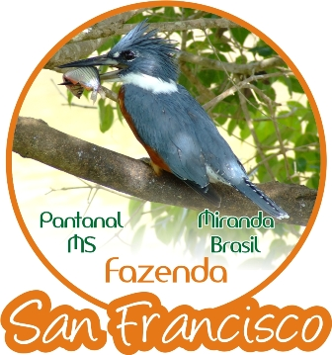
Fazenda San Francisco Agro-Ecoturismo
Pousada e Passeios no Pantanal Sul * Miranda
Mato Grosso do Sul * Brasil
www.fazendasanfrancisco.tur.br
http://blogpantanalfazendasanfrancisco.blogspot.com
MINISTÉRIO DO TURISMO: 12.006121.20.0001-1

WWW.fazendasanfrancisco.tur.br
Prices (4 days/3 nights):
SINGLE R$1584, 00 (ca. USD 820)
DOUBLE R$ 1.074,00 per person (ca. USD 560)
TRIPLE R$ 1.005,00 per person (ca. USD 520)
QUADRUPLE R$ 960, 00 per person (ca. USD 500)
Transfer: between R$400,00-R$500,00 (between USD 200-260)
Lodge includes: Tours and meals during the stay (03 meals + 03 tours per overnight + Insurance + Pantaneiro local Guide + Room equipped room Ar conditioning, private bathroom and mini-bar).
The tours / activities are:
- Photo Safari with suspended trail walk
- Chalana Boat Tour with Piranha fishing
- Horseback Riding
- Canoeing
- Trail walks
- “Night Ride Spotlighting”
- Pantaneiro Barbecue (Luau)
- Lectures about Pantanal

www.fazendasanfrancisco.tur.br
Phone: 55 (67) 3242-1088/ 3242-3333/ 9964-3431
E-mail: reservas@fazendasanfrancisco.tur.br
MSN: reservas_sanfrancisco@hotmail.com
SKYPE: reservas.sanfrancisco

