BOUTE EXPEDITIONS TOURS

PANTANAL, SERRA DAS ARARAS AND
CHAPADA DO GUIMARÃES NATIONAL PARK
(BIRDWATCHING)
1st. Day: Arrival at the International Airport in Cuiaba and immediate transfer to the Pantanal. Field observation and birdwatching on route. While crossing the area down the Transpantaneira dirt road, spectacular chances to spot many birdlife such a Jabiru, Wood Stork, Roseate Spoonbill, Southern Screamer, Plumbeous, Buff-necked, Bare-faced & Green Ibises, Sunbittern, Long-tailed Ground-Dove, Black-collared, Great Black & Savanna Hawks, Snail Kite, Chaco Chachalaca and many others. Arrival at the hotel at the end of the day. Check in. Sunset and Nighthawks watch, followed by some Owling. Dinner. Field Check List Track (FCT). Overnight.

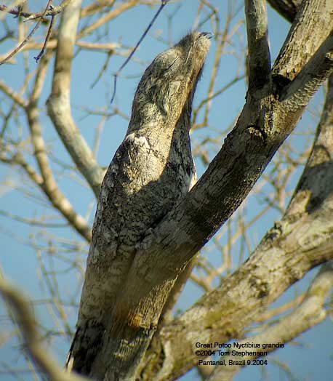
Great Potoo

2nd. Day: Early morning breakfast and birding on the gallery forest of the Pixaim river, good chances to spot the Helmeted Manakin, Rufous-tailed Jacamar, White-lored and Rusty-backed Spinetail, Mato Grosso and Band-tailed Antbird, Red-billed Scythebill, Flavescent Warbler, Moustached and Buff-bellied Wrens, Purplish Jay, Troupial, Crested Oropendola, Solitary Black-Cacique, Blue-crowned Trogon, Black-fronted Nunbird, Silver-beaked Tanager, Rusty-collared and White-bellied Seedeaters, Lesser Seed-Finch and many others. Return for lunch. PM: Boat ride, with chances to spot Anhinga, Rufescent-tiger, Striated and Boat-billed Herons, Gray-necked Wood-Rail, Sungrebe, Southern Lapwing, Lesser Kiskadee, Black-capped Donacobius. All the five South American Kingfishers, Band-tailed Nighthawk and many others. After dinner night tour to owling and spot nocturnal wildlife, including Ocelots!

3rd. Day: After Breakfast, we check out and transfer to another lodge with birding along the route with chances for Maguari Stork, Laughing Falcon, Whistling Heron, White-faced, Black-bellied & Muscovy Ducks, Bare-faced Curassow, Blue-throated Piping-Guan, Bay-winged & Giant Cowbird. We will move to a lodge with nesting Hyacinth Macaws and daytime roost for Great Potoo. This area is also "literally" packed with a great number of other birds. Check in. Lunch. Siesta. PM: Bird walk with chances to spot Rufous Cacholote, Red-crested & Yellow-billed Cardinal, Grayish & Buff-throated Saltator, White-rumped Monjita, Nacunda Nighthawk, Greater & Rufous-fronted Thornbird, Masked Gnatcatcher. Capped Heron, Toco Toucan, Chesnut-eared Aracari, Peach-fronted, Monk & Golden-chevroned Parakeets, Golden-collared Macaw, Striped Cuckoo, Scarlet-headed, Unicolored & Chopi Blackbirds, followed by some owling. FCT. Dinner. Overnight.

4th. Day: Breakfast. Farewell sights for the Hyacinth Macaws. Check out. Transfer to Serra das Araras. Field observation and birdwatching on route. Arrival at lodge, accommodation and afternoon Harpy Eagle watch, also chances to spot Gray Hawk, Yellow-tufted Woodpecker, Warbling Antbird, Magpie Tanager and many others. Night outing to look for: Least Nighthawk, Scissor-tailed Nightjar and Pauraque. Dinner. FCT. Overnight.

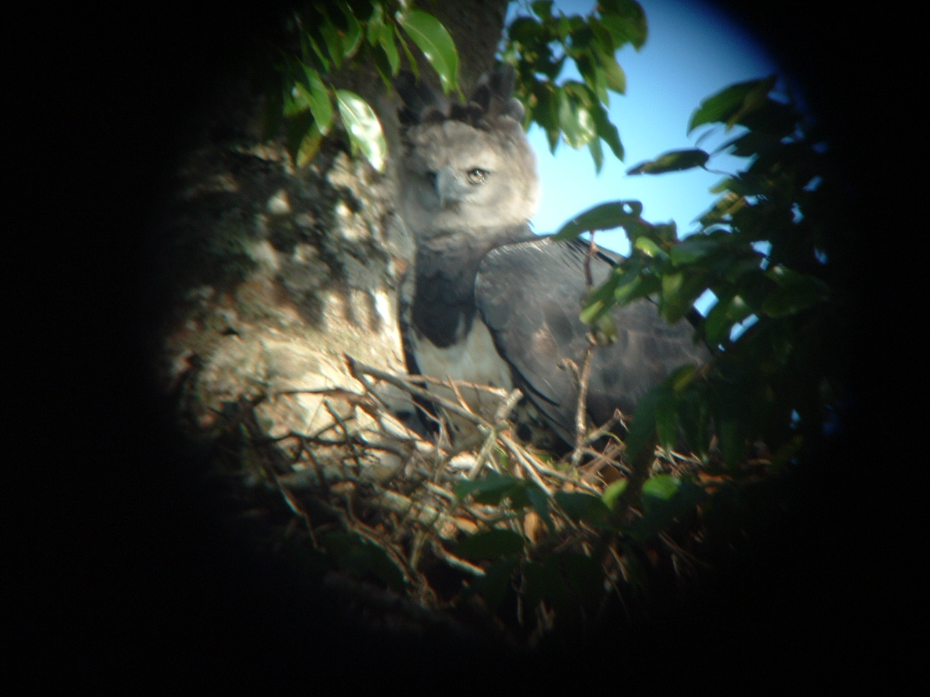
Harpy Eagle Photo by Paulo Boute - April, 2009

5th. Day: Breakfast. Early Birding with spectacular chances to spot many birdlife such: a King Vulture, Red-shouldered Macaw, Dusky-headed Parakeet, Sharpbill, White-flanked and Black-throated Antbirds, White-eyed Attila, Turquoise and White-shouldered Tanagers, and many others. Transfer to Chapada dos Guimarães, with birding and lunch in route. Arrival at Chapada in time for some great birding such: Blue-winged and Red-and-Green Macaw, Curl-crested Jay, Gray Monjita, Crested Black-Tyrant, Cliff Flycatcher and many others. Arrival at the hotel. Dinner. FCT. Overnight.

6th Day: Full day at Chapada. Our targets will be: Rufous-sided Pygmy-Tyrant, and cerrado specialties such as: Red-legged Seriema, Small-billed Tinamou, White-eared Puffbird, Collared Crescentchest, Horned Sungem, Yellow-billed Blue Finch, Rufous-winged Antshrike, Black-faced Tanager, Red-legged Seriema, White-eared Puffbird, White-rumped and White-banded Tanagers, Coal-crested Finch, Plumbeous Seedeater, Black-throated Saltator and many others. Lunch with some siesta break at our hotel. PM: Birdwatching at semi-deciduous forest, cerrado, canyons with chances to spot Yellow-ridged Toucan, Lettered Aracari, White-collared and Biscutate Swift, Blue-crowned Motmot, White-lined and Guira Tanager, Ochre-cheeked Spinetail, Plain Antvireo, Wedge-tailed Grass-Finch, and many others. Return to the Hotel. Owling. Dinner. FCT. Overnight.
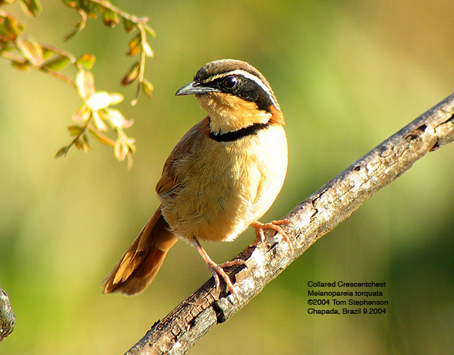
Collared Crescent-chest

7th. Day: Breakfast. AM: Full morning birding - Superb Special Targets: Band-tailed and Fire-Crowned Manakins and Southern Antpipit. Return to the Hotel. Check out. Transfer to Cuiaba. Check in at the airport. Lunch. Flight to Sao Paulo.

Price 2012: Pantanal, Serra das Araras and Chapada dos Guimarães National Park
Group of 02 and 03 people: US$2,486.00 per person in double room
Group of 04 and 05 people: US$2,116.00 per person in double room
Group of 06 and 07 people: US$1,866.00 per person in double room
Group of 08 people: US$1,719.00 per person in double room
Single Supplement: US$282,00
In the above cost:
It is included: all overnights, all meals, all ground transportation (with mineral water and air conditioning), bilingual guide full time, 06 hours of motor boat ride at the Pantanal and park fee.
It isn't included: internal and international flights, laundry service, beverages, telephone calls and any other personal item.

