Child Care

Baby-Sitters

Hotel Zagaia offers baby sitters for children of all ages that can be hired at the following costs:
R$100,00 (ca. USD50) for 8 day hours
R$120,00 (ca. USD60) for 8 evening hours
For further information on this service, please contact Gitane Klain at the e-mail <vendas@zagaia.com.br> or phone (67) 3255-5605.
Kids 1-3 years old

Hotel Zagaia offers a whole day of activities (between 09h00-22h50) for children between one and three years old. These children must be accompanied by an adult though. Costs for this activity are as follows:
Day pass for Zagaia guests – FREE (lunch not included)
Day pass for non-Zagaia guests – R$150 (ca. USD75)
In addition a special room (Espaço Kids) with toys and games for kids is also available at the hotel. For further information on these service, please contact Gitane Klain at the e-mail <vendas@zagaia.com.br> or phone (67) 3255-5605.
Kids 4-12 years old
Hotel Zagaia also offers a whole day of activities (between 09h00-22h50) for children between four and twelve years old. These children do not need be accompanied by an adult. Costs for this activity are as follows:
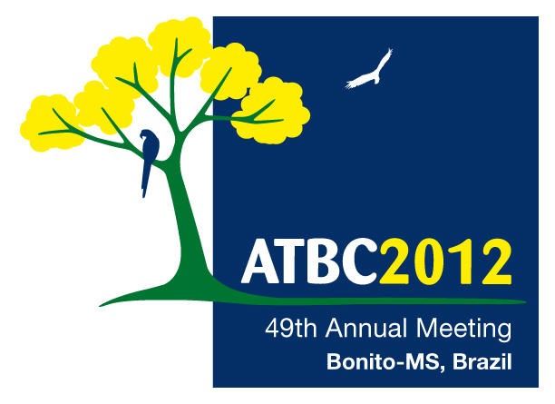
Day pass for Zagaia guests – FREE (lunch not included)
Day pass for non-Zagaia guests – R$150 (ca. USD75)
For further information on this service, please contact Gitane Klain at the e-mail <vendas@zagaia.com.br> or phone (67) 3255-5605.

